**SUMMER IS FINALLY HERE!**

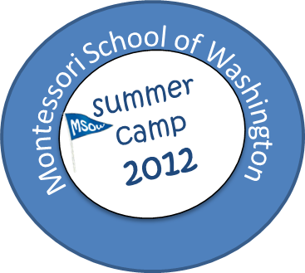**Learning through Play**

**Age 2-6**

Download Camp Flyer

Download Camp Registration Form

Payment Form

The twelve weeks program will highlight various activities to include Dance, Music, Fun-Fitness, Out-Door Playtime, Sports (soccer), Art & Craft, Yoga, Cooking, Pottery, Fieldtrips, to name a few. Our school is Montessori based, however, our summer camp revolves more around learning through fun in a safe and supportive environment.

Specialist instruction from our friends at Joy of Motion (Dance) and My Gym (Fun Fitness) will be integrated in our weekly curriculum.

**C:\Documents and Settings\mjames\Local Settings\Temporary Internet Files\Content.IE5\A2TW4WPT\MC900310986[1].wmf**

**Summer 2012 Camp Theme**

**Around the world in 60 Days!**

  
 *(Remind us to issue you your passports upon arrival)*  
  
**June ~ North America, South America and down under (Australia)**New Orleans: Mardi Gras, Bread pudding, Stained glass art  
Hawaii: A Luau day, Tropical treat, Tissue paper leis  
Brazil: Carnival,  Bean mosaics,  Latin American treat  
Australia: Nature walk,  Pottery: reef replica,  Lamingtons: Australian treat  
  
**July ~ Europe and Africa**   
France: Playing pétanque, Crepes, Crayon crackle painting  
Greece: Scavenger hunt, Mediterranean salad, Dry-wall sculpture  
Kenya: Safari adventure, Young runners, Quilting  
Morocco: Pottery: plates, Making couscous, Jewelry making  
  
**August ~ Asia and Good-bye Summer**  
India: Cricket, Veggie burgers, Fabric painting  
China: Tanagrams, Ribbon dancing, Lychee gel treats, Pressed flower art  
Summer Fun!

**GENERAL CAMP INFORMATION**

Important dates:   
MSOW offers 12 weeks of summer fun from 4 June to 24 August. We will follow DC public school's schedule for holidays and weather.  
There will be no camp on 4 July.  
  
**MSOW CAMP HOURS:**   
Early drop off: 8:15-9:00am ($10/hr.)  
Camp day: 9:00am-12:00pm  
                       9:00am-3:00pm  
After-care: 3:00-6:00pm ($10/hr.)  
  
**DROP OFF:**   
Our drop off location during camp sessions is: Hardy Park Corner of Q St. & Foxhall road  
* Drop off will be at MSOW on rainy days.  
  
**REGISTRATION AND DEPOSIT:**   
To reserve a space in MSOW camp, please complete the registration form and return to us with a $200 deposit for each session (week) you are registering for by April 30th.  
* Payment may be made by cash or check.  
* The balance of camp fees, all camp forms and an up-to-date health form are due the first day your child starts camp.  
  
**REFUNDS:**   
No refunds will be made for absences or withdrawals during the camp session.  
  
**FINAL CONFIRMATION:**

Please note that your child's registration is not final until you receive a confirmation email from [msow.dc@gmail.com](mailto:msow.dc@gmail.com) and all camp payments and documents have been received.